# CS 255 System Design Document Template

Christopher Goodwin

CS-255

## UML Diagrams

### UML Use Case Diagram

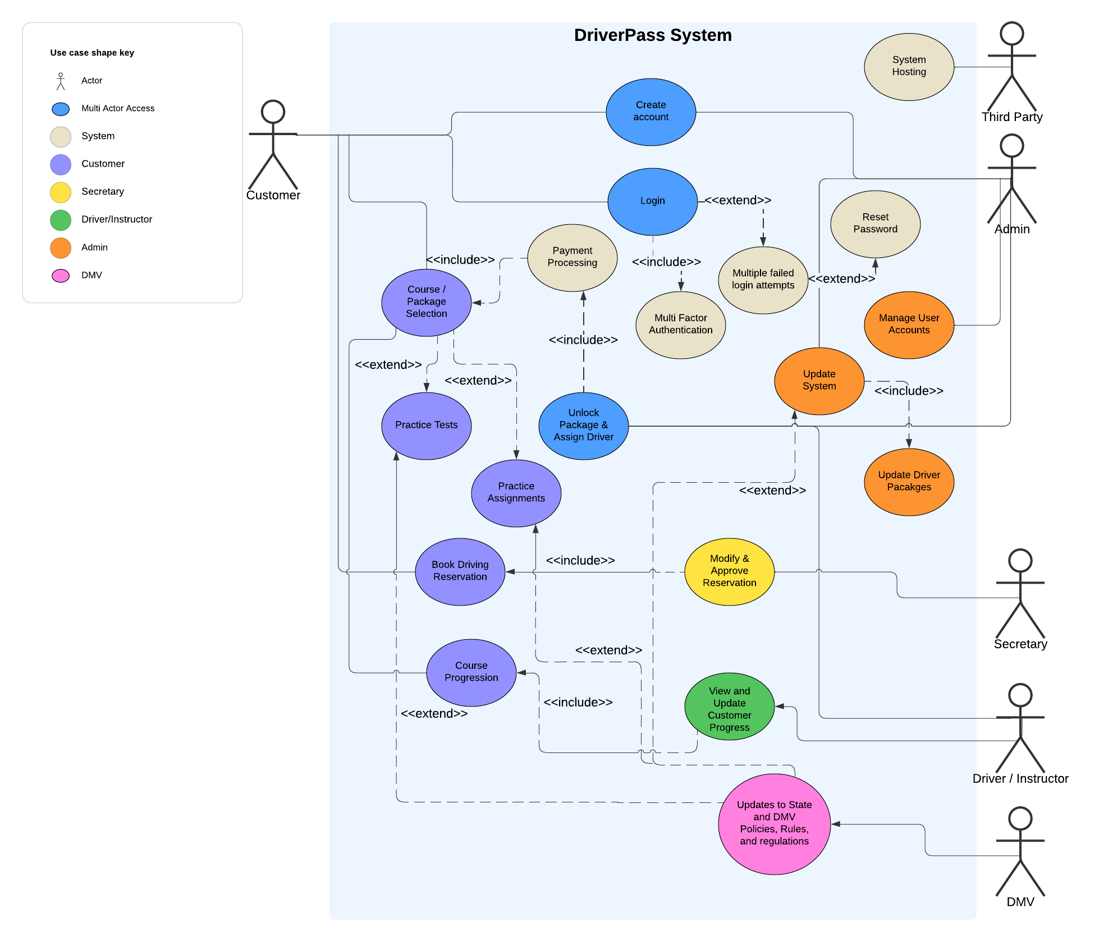

### UML Activity Diagrams

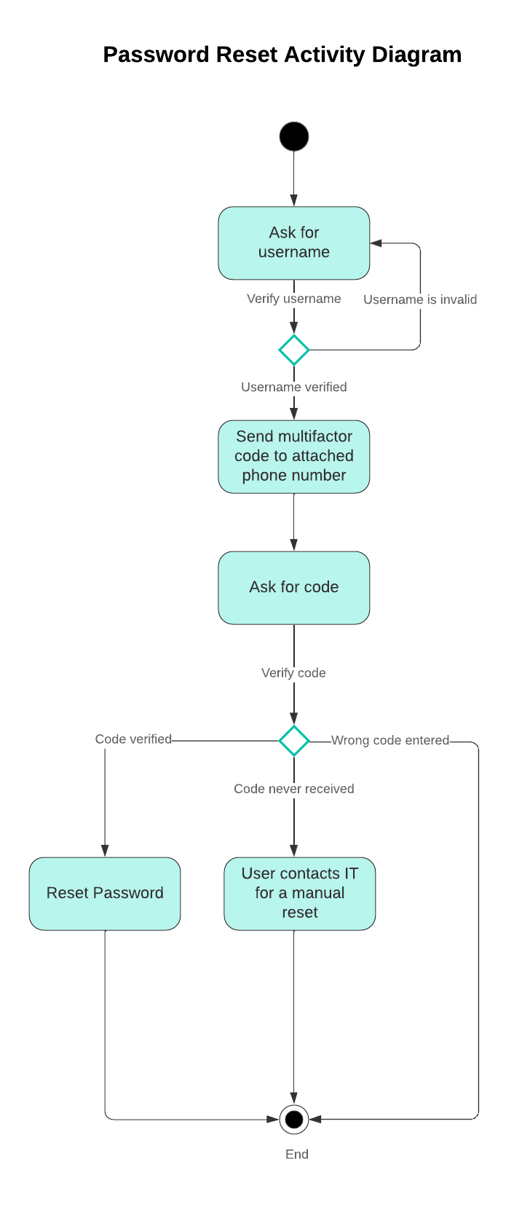

### 

### UML Sequence Diagram

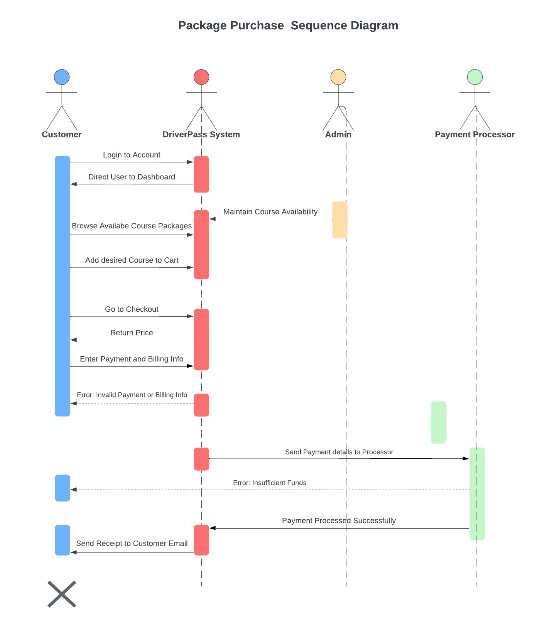

### UML Class Diagram

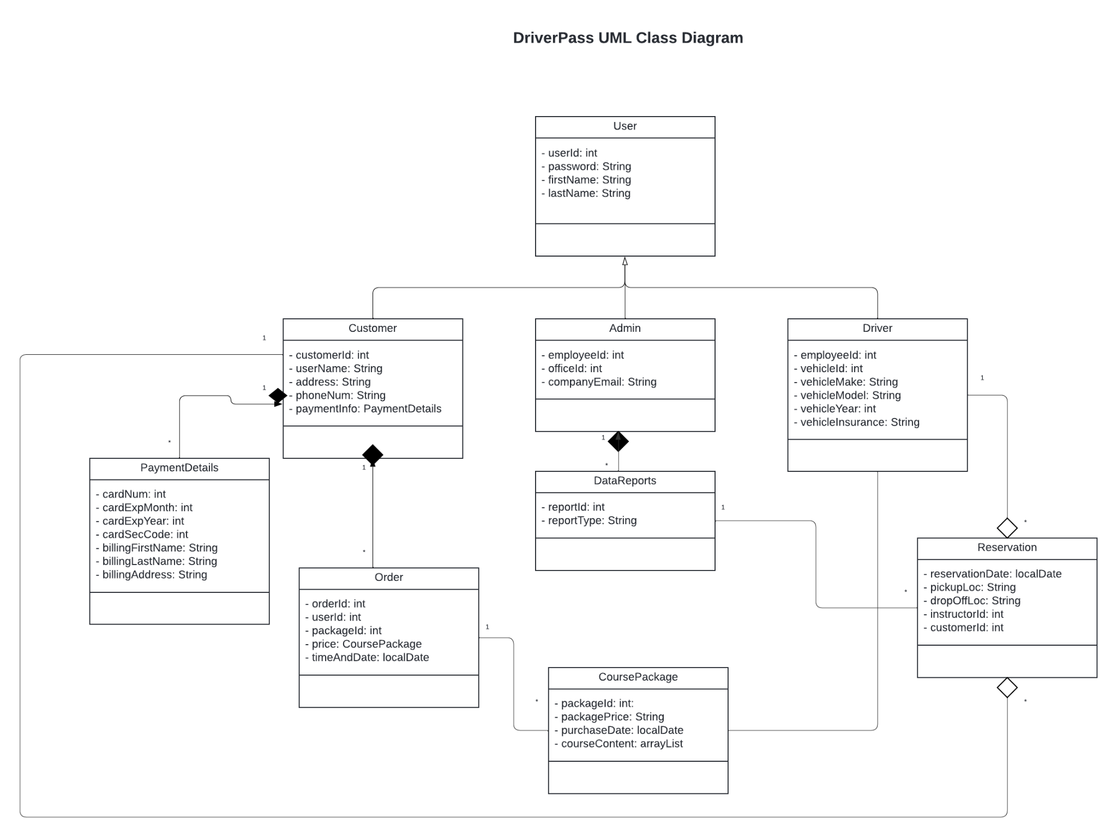

## Technical Requirements

*Host Requirements*

* *Internet Access*
* *Hardware Requirements*
  + *Work stations for Admin and IT*
    - *Desktops*
  + *Local-Network setup*
* *Software Requirements*
  + *Third Party Host*
    - *Hosting software*
  + *DriverPass System*
  + *Security Software*
  + *Cloud Based Storage*
* *Tool Requirements*
  + *Programming software for future updates*
  + *Admin tool suite*
    - *Network Monitoring*
    - *Firewall Software*
  + *Payment Processors*

*Client Requirements*

* *Internet Access*
* *Hardware Requirements*
  + *User Devices*
    - *Desktop*
    - *Laptop*
    - *Tablet*
    - *Smart Phone*
* *Software Requirements*
  + *Updated OS*
    - *Windows*
    - *MacOS*
    - *Linux*
  + *Supported Browser*
    - *Firefox*
    - *Brave*
    - *Chrome*
    - *Safari*
    - *Microsoft Edge*